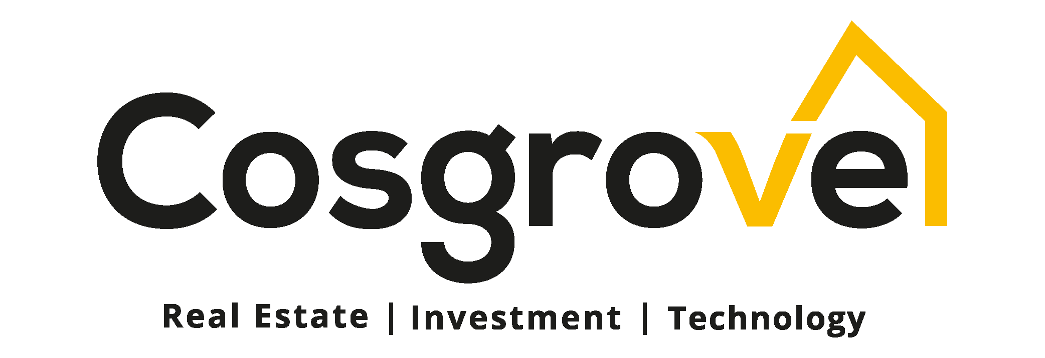

Date: dd/mm/ 2022
NAME:
ADDRESS:

AGENCY/ MARKETING AGREEMENT BETWEEN (YOUR NAME) AND COSGROVE INVESTMENT LIMITED
Thank you for your interest in marketing our product. Below are the terms and conditions of the contract:
1. PROCEDURE/SCOPE OF WORK (Digital Marketing)
- All Social Media materials and content will be provided by Cosgrove and copies will be sent to you for your social media use. You are prohibited from creating social media content on behalf of the COSGROVE brand.

- Deployed resources and staff for ground marketing is entirely up to you; and COSGROVE will not bear any costs related therein.

- Cosgrove will handle all of her Branding and Promotions solely.

- Strategy plan for the client’s house(s) such as (Notices of Payment or Payment Reminder letters, Newsletters and Revocation Letters) will be prepared by Cosgrove.

2. TIME TABLE: Cosgrove will assure you get all Marketing Tools/Essentials. E.g. (Newsletters and Brochure).
3. MARKETING/ MANAGEMENT FEE:

We are not under any obligation to pay (YOUR NAME) Marketing / Managerial fee. Cosgrove is responsible for managing its own organization.

Cosgrove Investment Limited shall pay a 5% commission to (YOUR NAME) for every sale and this should cover the marketing fee (5% commission) which will be paid on every instalment received by Cosgrove.
Cosgrove Investment Limited shall withhold payment of commission if client’s Application Form and Acknowledgement copies of offer letters are not returned.
To formally confirm your acceptance of this contract please sign and e-Mail to hauwa.labaran@cosgroveafrica.com within five (5) working days form the date of this letter.

Yours Faithfully,

AUTHORIZED SIGNATORY

For: Cosgrove Investment Limited

PASSPORT PHOTOGRAPH

We/I ________________________________ accept terms and conditions
of contract: Signature_______________ Phone Number: __________________
Email Address: _____________________ Date:_______________
ACCOUNT INFORMATION:
Account Name___________________ Bank: _________ Account Number: ______________

